SUBLIST3R TOOL – COMPREHENSIVE TECHNICAL DOCUMENTATION
An OSINT-Based Subdomain Enumeration Tool for Ethical Hacking & Penetration Testing
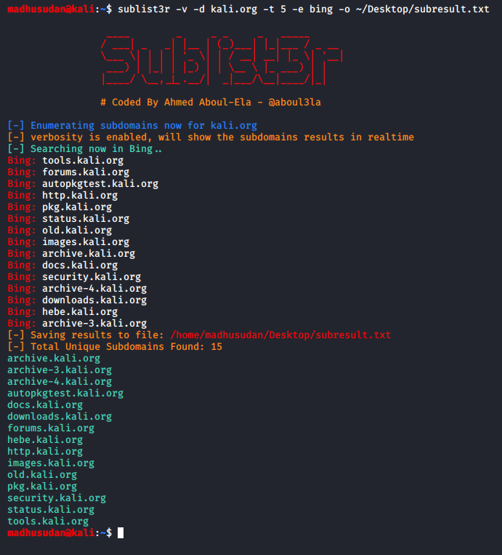
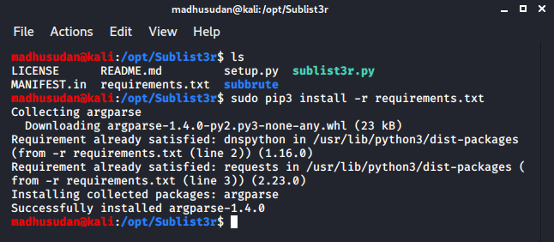
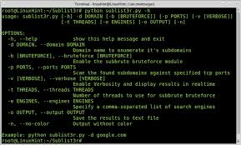

ABSTRACT
Subdomain discovery is a critical step in the reconnaissance phase of penetration testing, as it helps identify exposed services that may otherwise remain unnoticed. Modern organizations host numerous subdomains for development, cloud services, APIs, and third-party integrations. This document presents a comprehensive technical analysis of Sublist3r, an open-source subdomain enumeration tool that leverages Open-Source Intelligence (OSINT) techniques. The report explains the theoretical background, internal working methodology, command usage, practical case study, advantages, limitations, and defensive considerations of Sublist3r. The objective of this document is to provide an academic yet practical understanding of Sublist3r suitable for cybersecurity coursework and professional penetration testing studies.

1. INTRODUCTION
In today’s digital ecosystem, organizations rely heavily on distributed web architectures. Instead of hosting services on a single domain, they deploy multiple subdomains for various purposes such as authentication, APIs, staging environments, and content delivery networks. While this improves scalability and performance, it also increases the attack surface.
Subdomain enumeration allows security testers to identify these publicly exposed assets. Unlike brute-force approaches, OSINT-based enumeration uses publicly available data sources such as search engines, certificate transparency logs, and threat intelligence platforms.
Sublist3r is a powerful OSINT-based subdomain enumeration tool designed to collect subdomains without aggressively interacting with the target infrastructure. This document explores Sublist3r in detail and highlights its role in ethical hacking.

2. OBJECTIVE OF THE STUDY
The objectives of this documentation are:
- To understand OSINT-based subdomain enumeration
- To study the working mechanism of Sublist3r
- To analyze Sublist3r commands and options
- To demonstrate real-world usage through a case study
- To evaluate strengths, limitations, and security implications
- To provide exam-ready and submission-ready material

3. BACKGROUND: OSINT IN DNS RECONNAISSANCE
Open-Source Intelligence (OSINT) refers to intelligence collected from publicly available sources without direct interaction with the target systems. In cyber security, OSINT is widely used during reconnaissance to reduce detection risks.
OSINT-based subdomain enumeration can reveal:
- API endpoints
- Cloud-hosted services
- Forgotten or deprecated subdomains
- Third-party integrations
- Assets exposed via SSL certificates
Sublist3r utilizes multiple OSINT sources to identify subdomains efficiently and silently.

4. OVERVIEW OF SUBLIST3R TOOL
Sublist3r is an open-source Python-based subdomain enumeration tool developed for penetration testers and bug bounty hunters. It aggregates results from multiple OSINT sources such as search engines, DNS records, and SSL certificate data.
Unlike brute-force tools, Sublist3r focuses on passive reconnaissance, making it less noisy and harder to detect. It is particularly useful during the early stages of penetration testing when stealth is required.
Sublist3r does not perform vulnerability scanning or exploitation. Its primary purpose is to enumerate subdomains and prepare a target list for further security testing.

5. ARCHITECTURE AND WORKING MECHANISM
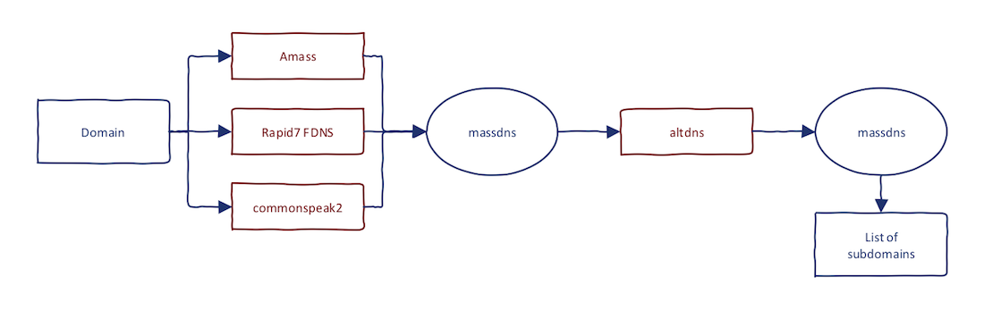
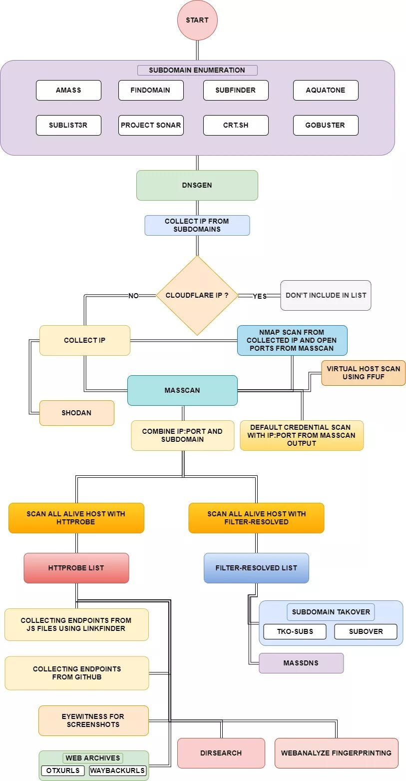
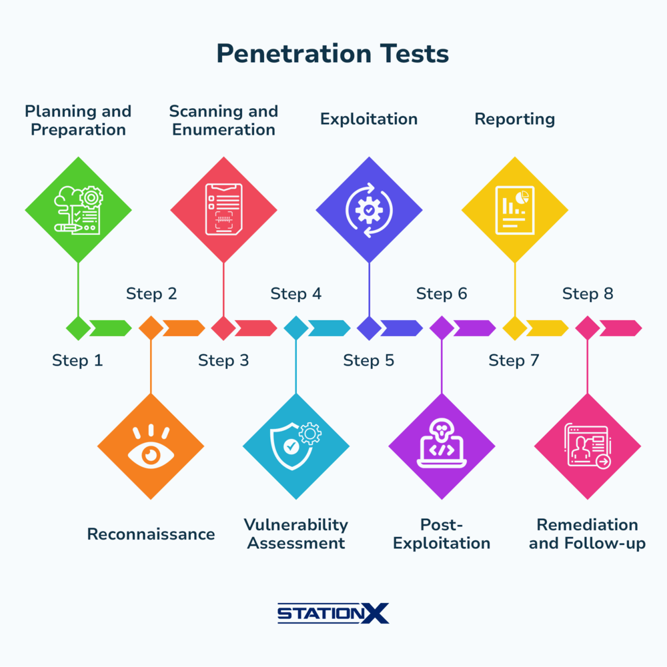
Sublist3r follows a multi-source intelligence collection process:
- Target Domain Input
The user provides the main domain name as input.
- Search Engine Enumeration
Sublist3r queries multiple search engines for indexed subdomains.
- SSL Certificate Analysis
Certificate transparency logs are analyzed to extract domain names.
- DNS Resolution
Identified subdomains are validated using DNS resolution.
- Result Aggregation
All discovered subdomains are consolidated into a single output.
This approach enables wide coverage without aggressive interaction with the target.

6. INSTALLATION AND ENVIRONMENT
Sublist3r is commonly available in Kali Linux and can also be installed manually using GitHub.
To verify installation:
sublist3r --help
Sublist3r requires Python and internet connectivity to access OSINT data sources.

7. COMMAND USAGE AND ANALYSIS
7.1 Basic Subdomain Enumeration
sublist3r -d example.com
Performs OSINT-based subdomain enumeration using default data sources.

7.2 Specifying Number of Threads
sublist3r -d example.com -t 50
Controls the speed of enumeration by adjusting parallel requests.

7.3 Saving Output to File
sublist3r -d example.com -o sublist3r_results.txt
Stores discovered subdomains for reporting or further testing.

7.4 Enabling Verbose Mode
sublist3r -d example.com -v
Displays detailed execution logs useful for learning and debugging.

7.5 Port Scanning Integration
sublist3r -d example.com -p 80,443
Performs basic port scanning on discovered subdomains.

8. PRACTICAL CASE STUDY
Scenario
An ethical hacking assessment is conducted on a fictional organization named example-corp.com.
Execution
sublist3r -d example-corp.com
Observations
- api.example-corp.com exposed backend services
- dev.example-corp.com revealed a staging environment
- cdn.example-corp.com indicated third-party integrations
Impact Analysis
The OSINT-discovered subdomains significantly expanded the scope for further scanning and vulnerability assessment without alerting the target systems.

9. ADVANTAGES OF SUBLIST3R
- Passive and stealthy reconnaissance
- Aggregates multiple OSINT sources
- Beginner-friendly and widely used
- Ideal for bug bounty and red team engagements
- Minimal impact on target infrastructure

10. LIMITATIONS OF SUBLIST3R
- Dependent on external OSINT sources
- May miss non-indexed or internal subdomains
- Slower than pure brute-force tools
- Requires internet access

11. SUBLIST3R VS OTHER ENUMERATION TOOLS
Tool | Technique | Strength
Sublist3r | OSINT-based | Stealth
DNSMAP | Brute force | Speed
DNSENUM | Mixed methods | Depth
AMASS | Hybrid (OSINT + brute) | Scale
Sublist3r is best suited for silent reconnaissance and early-stage enumeration.

12. SECURITY AND DEFENSIVE CONSIDERATIONS
Organizations can reduce OSINT exposure by:
- Monitoring certificate transparency logs
- Minimizing unnecessary public subdomains
- Regular asset inventory audits
- Applying access controls on exposed services

13. LEGAL AND ETHICAL CONSIDERATIONS
Sublist3r must be used only on domains where explicit authorization has been granted. Even passive reconnaissance can violate organizational or legal boundaries if misused.

14. CONCLUSION
Sublist3r demonstrates how much information about an organization’s infrastructure can be gathered using publicly available sources. Its passive nature makes it a valuable tool for ethical hackers seeking stealthy reconnaissance. Understanding Sublist3r equips cybersecurity students and professionals with essential skills for modern penetration testing and red team operations.

15. REFERENCES
- Kali Linux Official Documentation
- OWASP Information Gathering Guide
- OSINT Framework
- Certificate Transparency Logs

